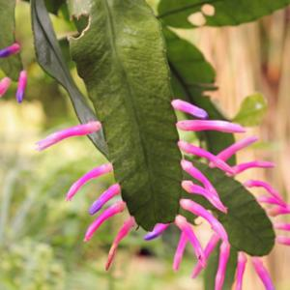

**Disocactus**

*Wittia amazonica*

(<https://garden.org/pics/2016-05-14/RuuddeBlock/f21cd8-300.jpg>)

**Category:**

Tropicals and Tender Perennials

Cactus and Succulents

Epiphytes

**Water Requirements:**

Average Water Needs; Water regularly; do not overwater

**Where to Grow:**

Suitable for growing in containers

This plant is suitable for growing indoors

**Height:**

6-12 in. (15-30 cm)

12-18 in. (30-45 cm)

**Spacing:**

6-9 in. (15-22 cm)

9-12 in. (22-30 cm)

12-15 in. (30-38 cm)

**Hardiness:**

USDA Zone 10b: to 1.7 °C (35 °F)

USDA Zone 11: above 4.5 °C (40 °F)

**Sun Exposure:**

Light Shade

**Danger:**

Plant has spines or sharp edges; use extreme caution when handling

**Bloom Color:**

Pink

Red

White/Near White

**Bloom Time:**

Mid Spring

Late Spring/Early Summer

**Foliage:**

Evergreen

Succulent

Rubbery-Textured

**Soil pH requirements:**

6.1 to 6.5 (mildly acidic)

6.6 to 7.5 (neutral)

7.6 to 7.8 (mildly alkaline)

**Patent Information:**

Non-patented

**Propagation Methods:**

From woody stem cuttings

Allow cut surface to callous over before planting

From seed; sow indoors before last frost

**Seed Collecting:**

Allow unblemished fruit to ripen; clean and dry seeds

Unblemished fruit must be significantly overripe before harvesting seed; clean and dry seeds

Properly cleaned, seed can be successfully stored